Pratical 1 LINUX

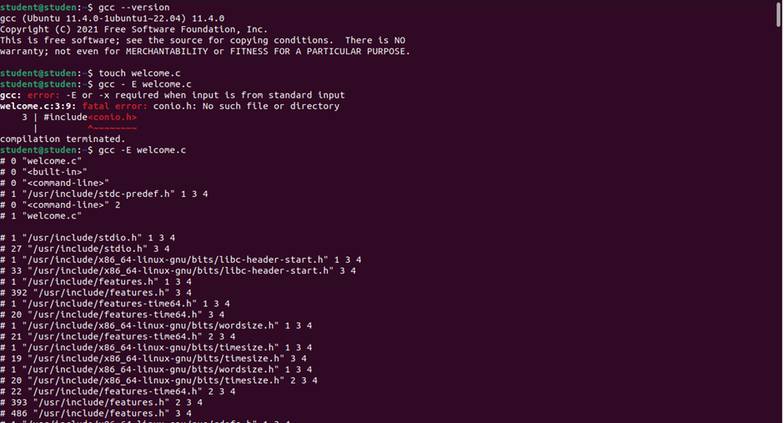

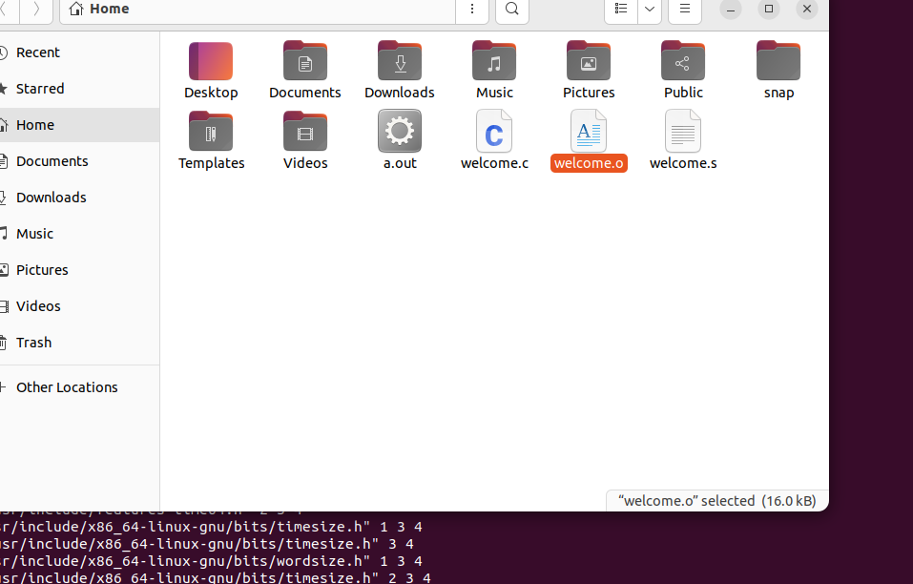

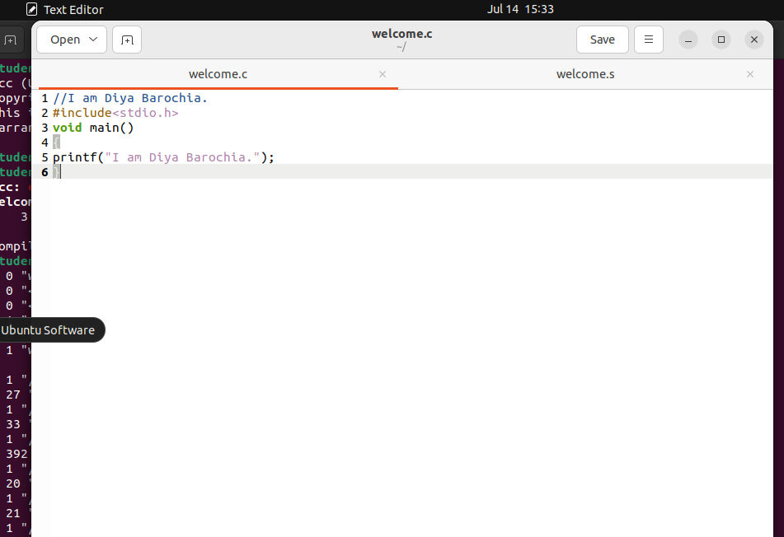

Write gcc –E welcome.c

Then click enter

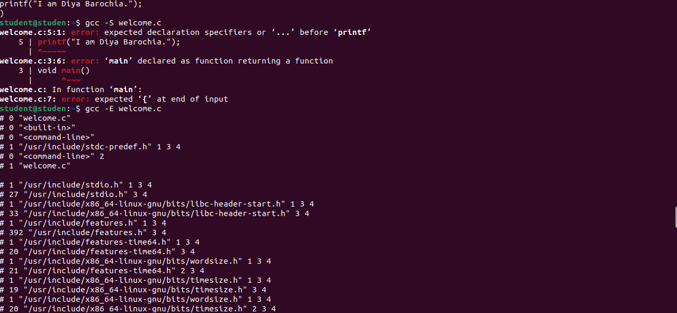

Now gcc – S welcome.c

Then enter , new file will be formed welcome.s

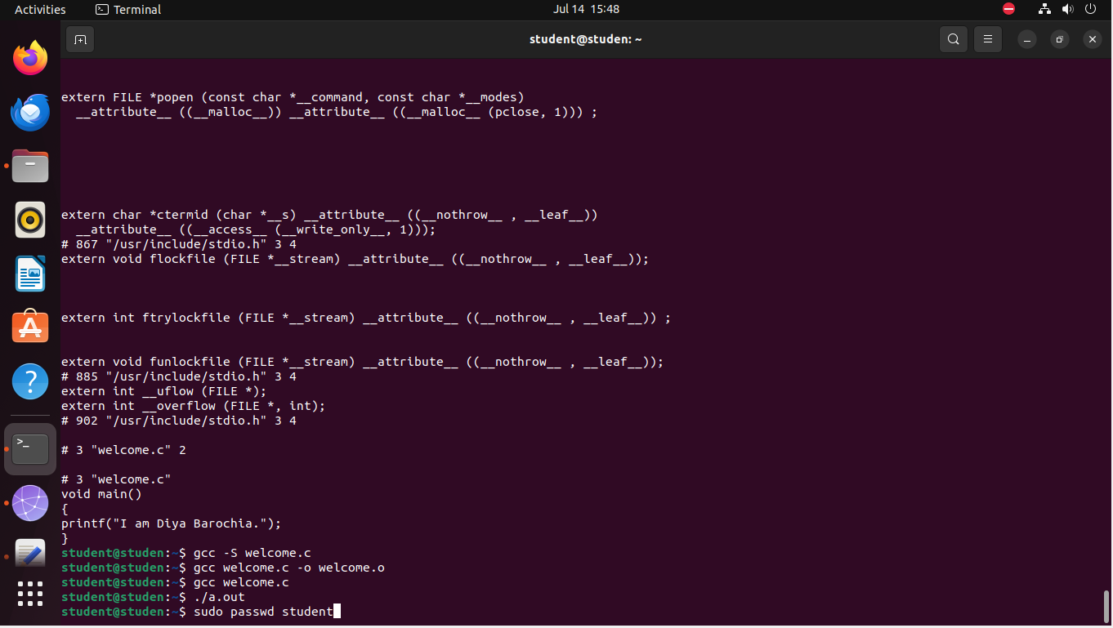

Then type gcc welcome.c –o welcome.o and enter it

Then welcome.o file will be formed which will be in terms of 0 and 1

Then type ./a.out

So new a.out will be formed

CODE BLOCKSTTT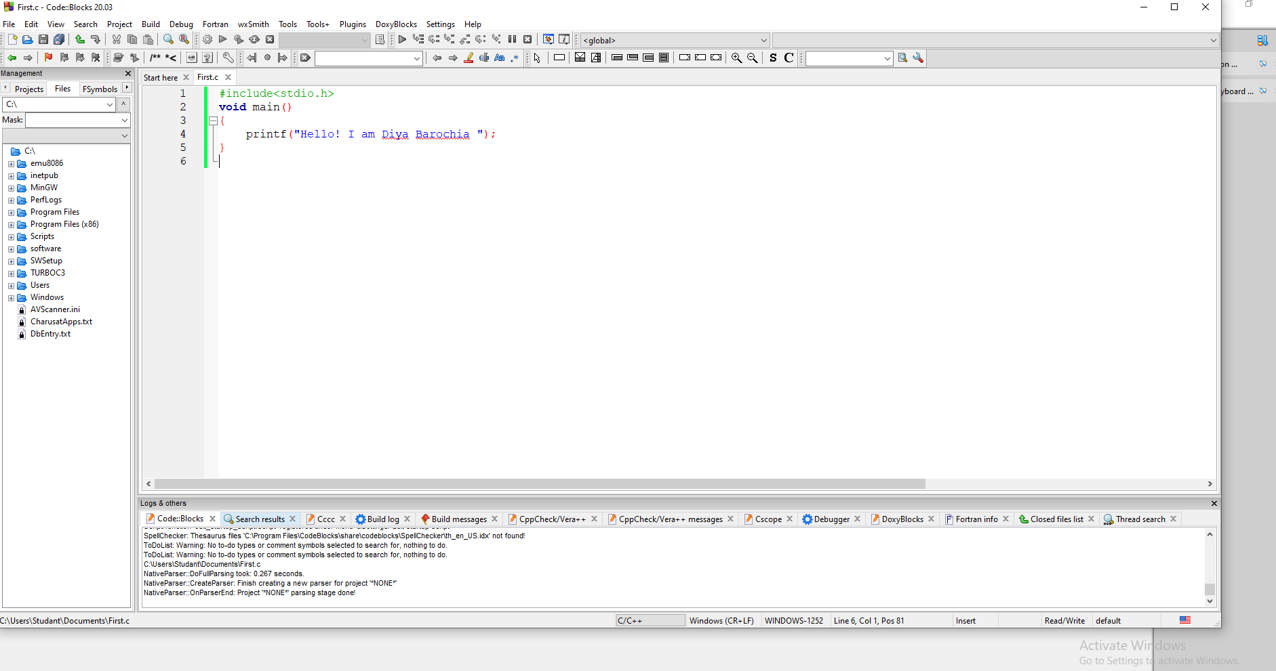

THIS DOWN BLUE SCREEN IS OF TURBO

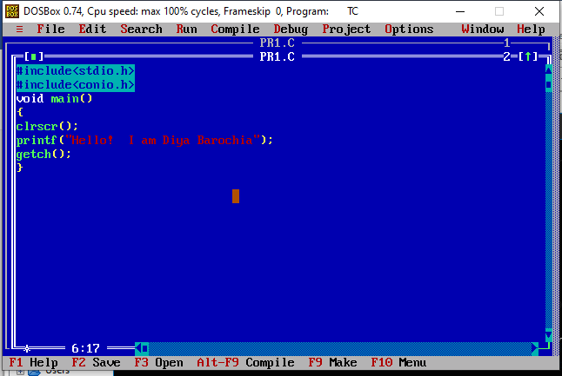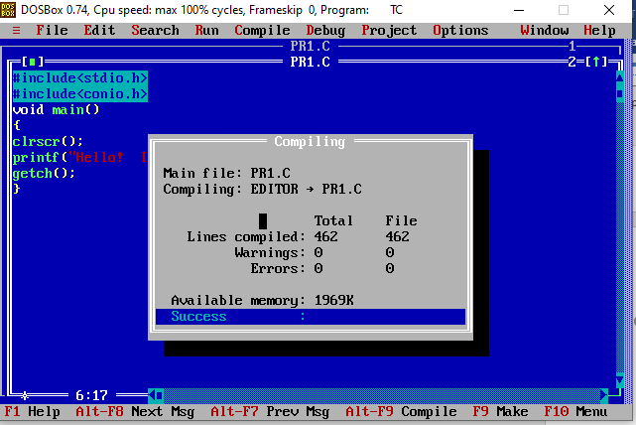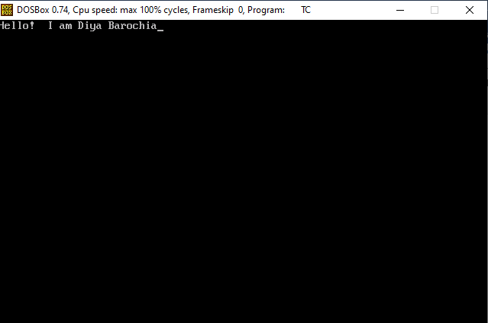

Rectangle park area and perimeter

